TITLE:
COURIER MANAGEMENT SYSTEM

Name: M.Mukesh
Course: B.Sc .Artificial Intelligence
College: E.S arts and science college
Project Title: Courier Management
System
Platform: Salesforce
Year: 2026

S. No | Title | Page No
1 | Abstract | 1
2 | Introduction | 2
3 | Objectives of the Project | 3
4 | System Requirements | 4
5 | Technology Used | 5
6 | System Design | 6
7 | Project Implementation | 7
7.1 | Creating Salesforce Developer Account | 8
7.2 | Creation of Custom Objects | 9
7.3 | Creation of Tabs | 10
7.4 | Creation of Fields | 11
7.5 | Relationships Between Objects | 12
7.6 | Validation Rules | 13
7.7 | Page Layout Design | 14
7.8 | Flow Automation | 15
7.9 | Lightning App Creation | 16
7.10 | Profiles and Roles | 17
7.11 | User Creation | 18
8 | Reports and Dashboards | 19
9 | Testing | 20
10 | Advantages | 21
11 | Limitations | 22
12 | Future Enhancements | 23
13 | Conclusion | 24
14 | Appendix | 25
15 | References | 26

ABSTRACT

The Courier Management System (CMS) is a cloud-based application developed using the Salesforce platform to automate courier operations. Traditional courier systems rely on manual record keeping which leads to delays, errors, and lack of shipment tracking. The proposed system provides centralized management of customers, shipments, delivery agents, and invoices.
The system enables shipment booking, tracking, automated delivery status updates, and report generation. Through Salesforce automation tools such as objects, validation rules, flows, and dashboards, the system improves operational efficiency and provides real-time visibility of courier operations.

1. INTRODUCTION
Courier companies handle a large number of shipments daily. Managing these shipments manually can cause several issues such as lost records, delayed updates, and inefficient delivery assignments.
The Courier Management System is designed to automate courier operations using Salesforce. It allows organizations to track shipments, manage delivery agents, monitor deliveries, and generate reports through a centralized cloud platform.

2. OBJECTIVES OF THE PROJECT
The main objectives of the project are:
- To automate courier operations
- To manage customer and shipment data efficiently
- To track shipment status in real time
- To assign delivery agents to shipments
- To generate reports and dashboards for analysis
- To improve delivery management and customer satisfaction

3. SYSTEM REQUIREMENTS

Hardware Requirements
- Computer or Laptop
- Minimum 4GB RAM
- Internet Connection

Software Requirements
- Salesforce Developer Account
- Web Browser (Chrome / Edge)
- Operating System: Windows

4. TECHNOLOGY USED
Layer | Technology
User Interface | Salesforce Lightning
Backend Logic | Salesforce Flows
Database | Salesforce Objects
Automation | Validation Rules
Security | Profiles and Roles
Reporting | Reports & Dashboards

5. SYSTEM DESIGN
The system consists of the following components:
- Customer Management
- Shipment Management
- Delivery Agent Management
- Branch Management • Delivery Updates
- Invoice Management
- Reports and Dashboards
These components interact with each other to manage courier operations effectively.

6. PROJECT IMPLEMENTATION

6.1 Creating Salesforce Developer Account
First, a Salesforce developer account was created by registering on the Salesforce developer portal.
Steps followed:
- Open Salesforce Developer Signup page
- Enter personal details
- Verify email account
- Login to Salesforce dashboard
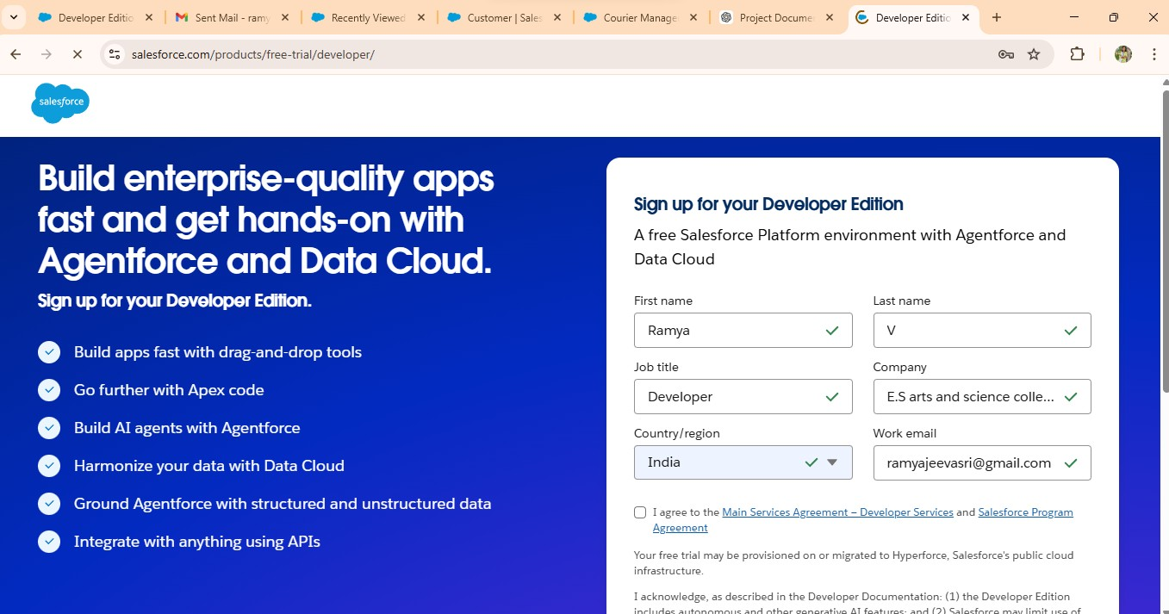

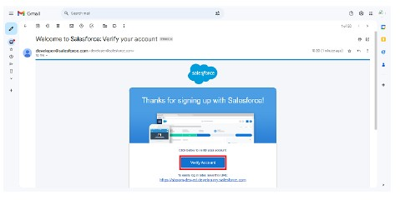

6.2 Creation of Custom Objects
Custom objects were created to store courier system data.
Objects created:
- Customer
- Shipment
- Delivery Agent
- Branch
- Delivery Update
- Invoice
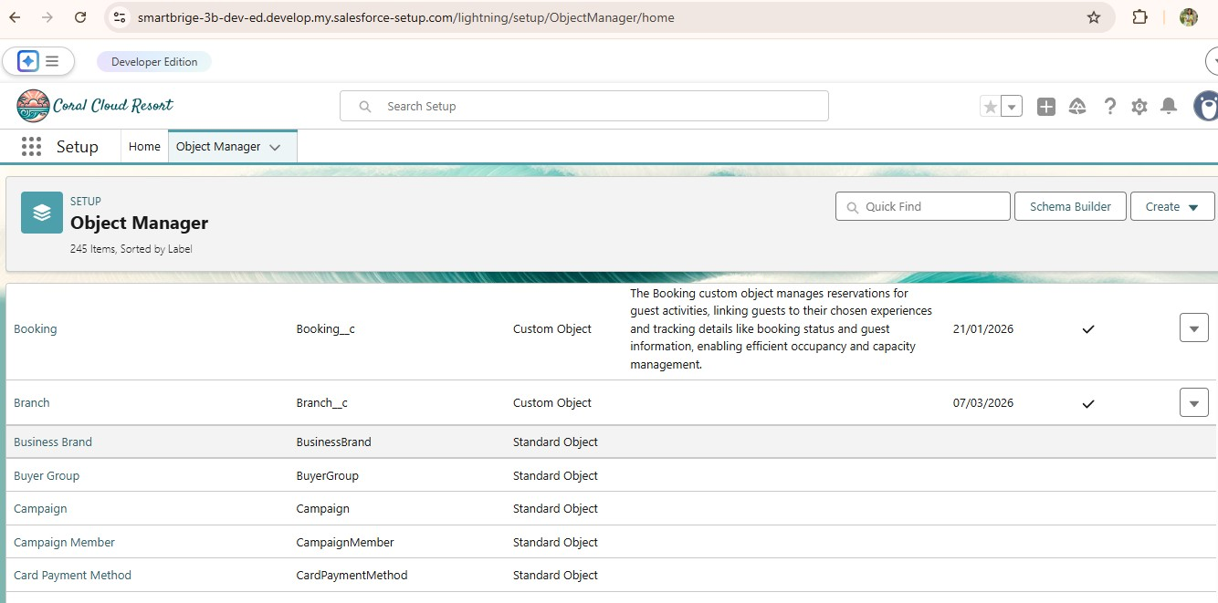

6.3 Creation of Tabs
Tabs were created for each custom object to allow users to easily access the data from the application interface.
Tabs created:
- Customer Tab
- Shipment Tab
- Delivery Agent Tab
- Branch Tab
- Delivery Update Tab
- Invoice Tab
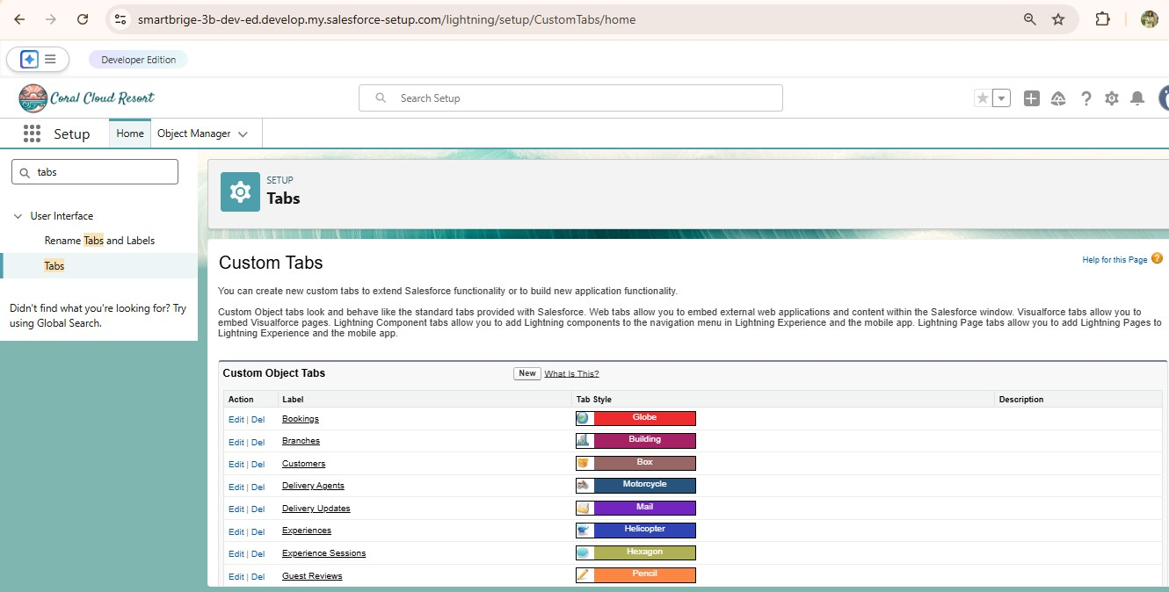

6.4 Creation of Fields
Fields were created inside each object to store the necessary data.
Example fields:
- Customer Object
- Name
- Email
- Phone
- Address
Shipment Object
- Tracking Number
- Source Address
- Destination Address
- Status
- Expected Date
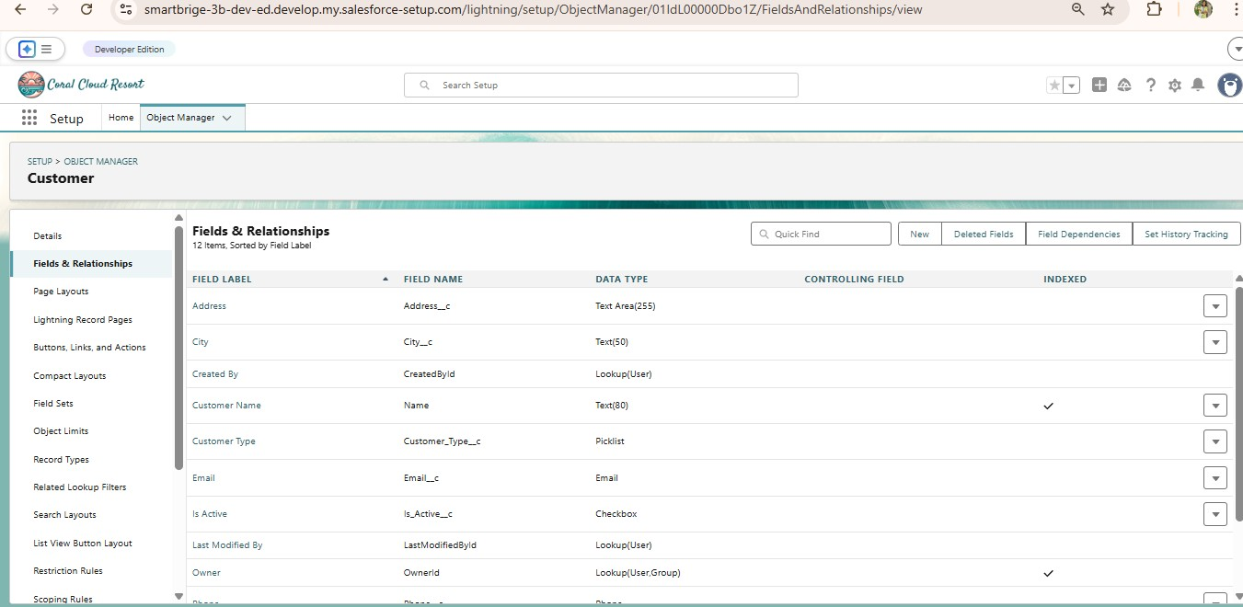

6.5 Relationships Between Objects
Relationships were created to connect different objects.
Examples:
- Shipment linked with Customer
- Shipment assigned to Delivery Agent
- Delivery Update linked to Shipment
- Invoice linked to Shipment
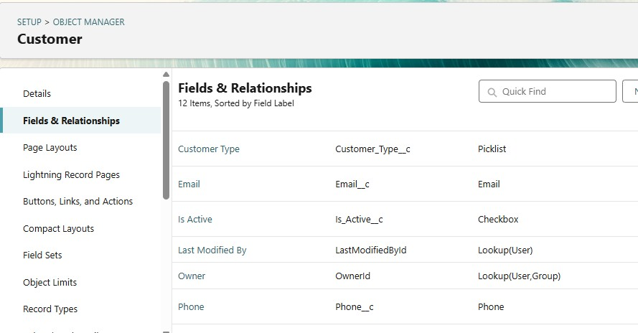

6.6 Validation Rules
Validation rules were implemented to ensure data accuracy.
Examples:
- Phone number must contain 10 digits
- Pincode must contain 6 digits
- Shipment weight must be greater than zero
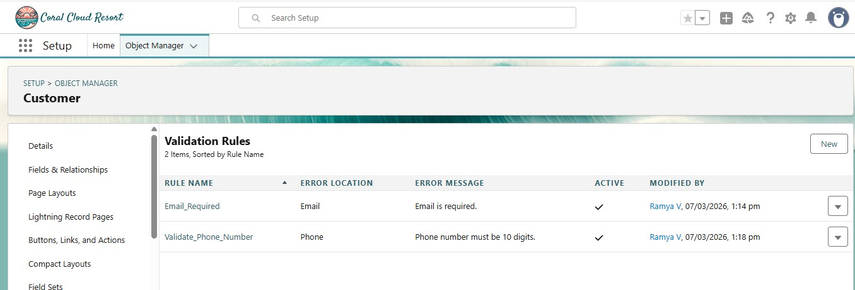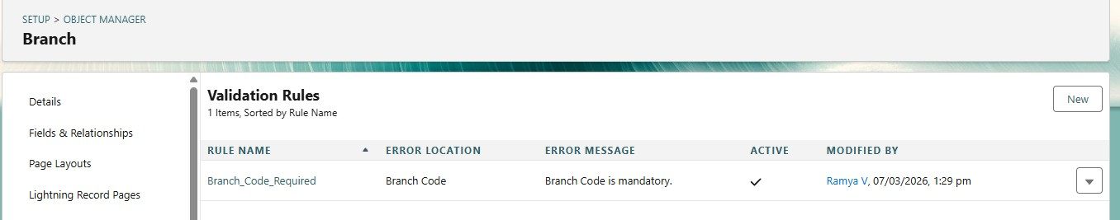

6.7 Page Layout Design
Page layouts were customized to organize fields in a structured manner for better usability.
Sections created:
Customer Layout
- Customer Information
- Address Details
Shipment Layout
- Shipment Details
- Delivery Details
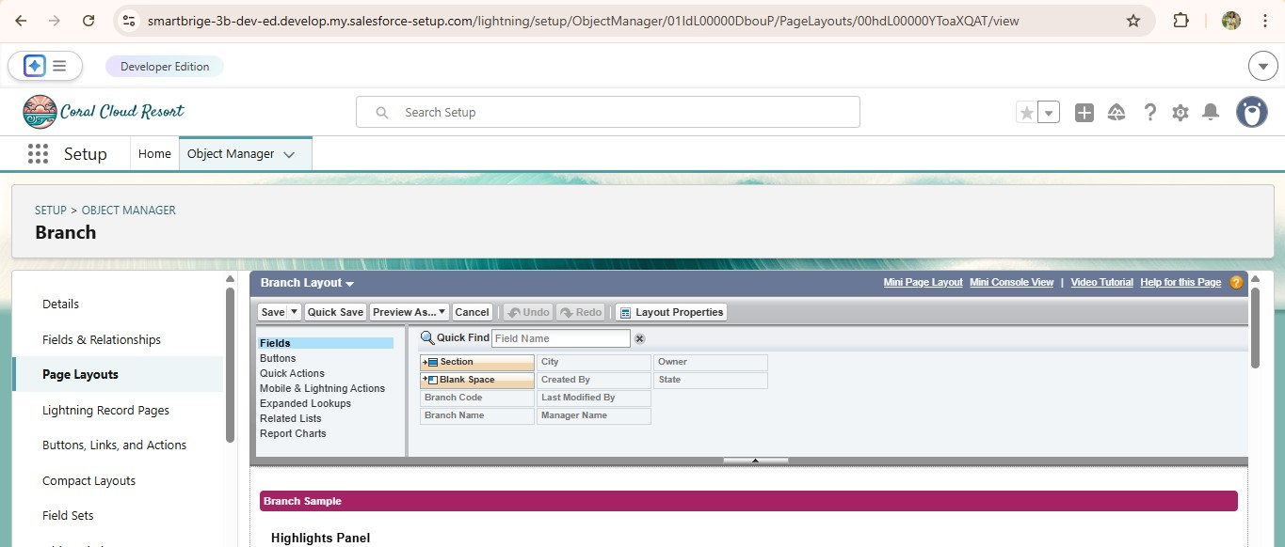

6.8 Flow Automation
A record-triggered flow was created to automatically update shipment status whenever a delivery update is recorded.
Example:
When delivery update status = Delivered
Shipment status automatically becomes Delivered.
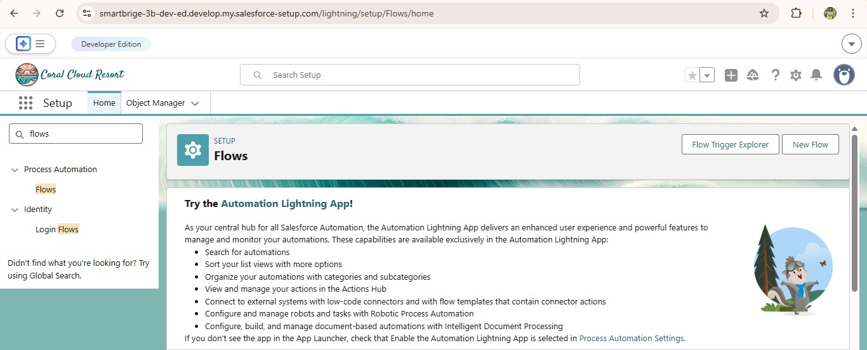

6.9 Lightning App Creation
A Lightning application called Courier Management System was created to group all related tabs and objects together.
The application includes:
- Customer
- Shipment
- Delivery Agent
- Branch
- Delivery Update
- Invoice
- Reports
- Dashboards

6.10 Profiles and Roles
Profiles and roles were created to manage system access.
Profiles created:
- Courier Admin
- Branch Manager
- Delivery Agent
- Customer Support Roles created:
- Courier Admin
- Branch Manager
- Delivery Agent
- Customer Support
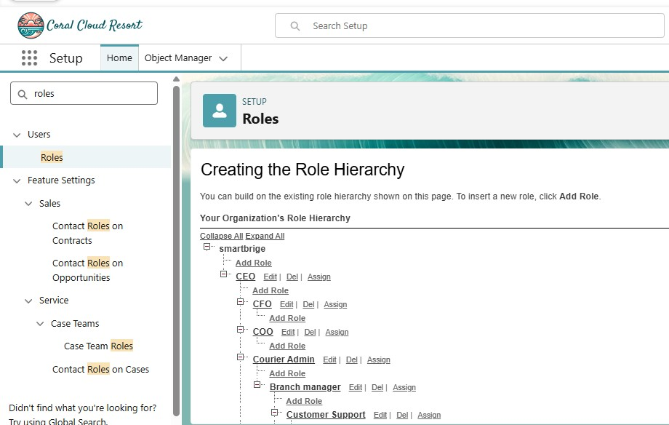

6.11 User Creation
Users were created and assigned roles and profiles according to their responsibilities. Example:
Branch Manager
Delivery Agent
Customer Support
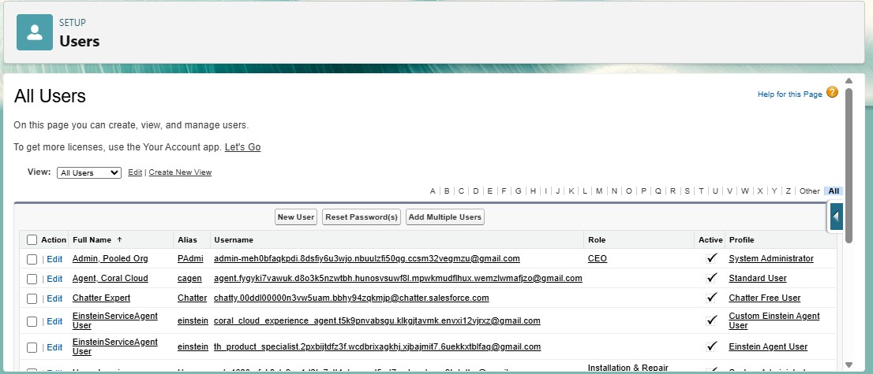

7. REPORTS AND DASHBOARDS
Reports and dashboards were created to monitor courier operations.
Reports:
- Shipment Status Report
- Agent Performance Report
- Revenue Report
Dashboard Components:
- Shipment Status Chart
- Agent Performance Chart
- Revenue by Branch Chart
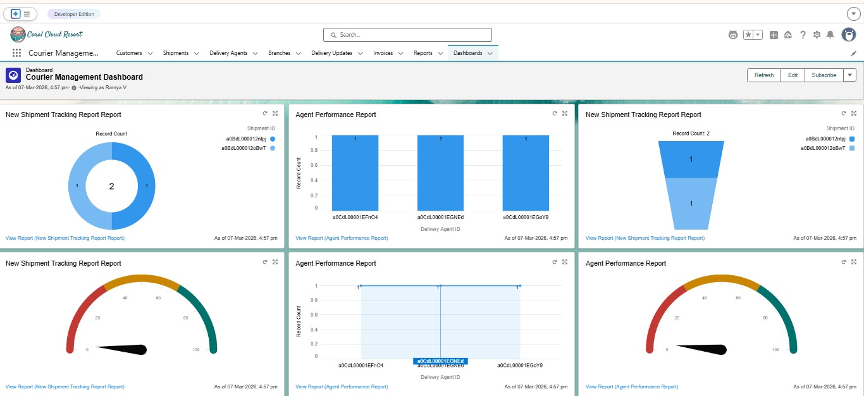

8. TESTING
The system was tested by creating sample records.
Test cases:
- Creating customer record
- Booking shipment
- Updating delivery status
- Generating invoice
- Viewing reports
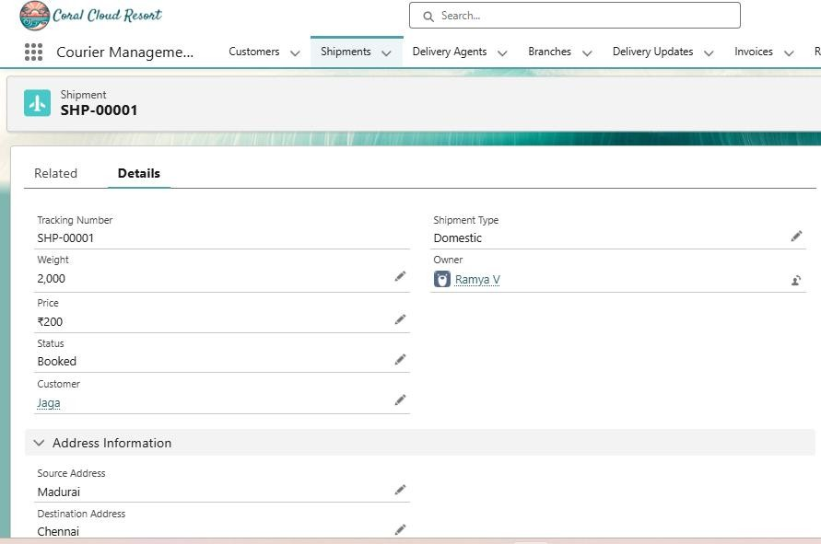

9. ADVANTAGES
- Centralized courier data management
- Automated shipment tracking
- Improved delivery management
- Real-time reporting
- Reduced manual work

10. LIMITATIONS
- Requires internet connection
- Depends on Salesforce platform
- Initial setup requires configuration

11. FUTURE ENHANCEMENTS
- Mobile courier tracking application
- GPS tracking integration
- SMS notification system
- AI-based delivery route optimization

12. CONCLUSION
The Courier Management System successfully automates courier operations using Salesforce. The system enables efficient shipment tracking, delivery management, and reporting through a centralized platform. By implementing automation and data management features, the system improves operational efficiency and customer satisfaction.

